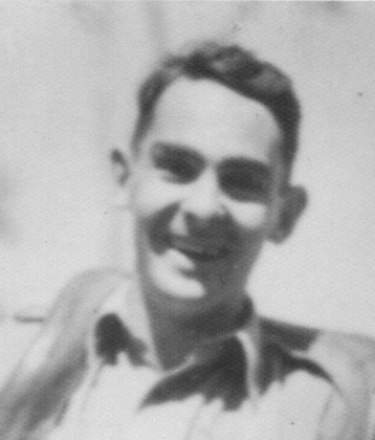
BRIAN ALEXANDER EVELYN HALEY

Parents: LYN & GWLADYS HALEY
Born : 4 August 1914
Sydney
Died: 1 July 1945
Ambon Island Prisoner of War Camp, Indonesia
Buried: Ambon War Cemetery, Ambon, Maluku, Indonesia

The family was living at Booberoi, Euabalong when Brian was born at Clarmore Private Hospital in Liverpool Hospital, Darlinghurst. Like his sisters, while living at Te Koona Brian corresponded with Cinderella in the Children’s Pages run by the Sydney Mail newspaper, having at least one letter published. Brian and his younger brother Pat were close in age and good friends and they seemed to get into a lot of mischief together (more details in Pat’s biography).

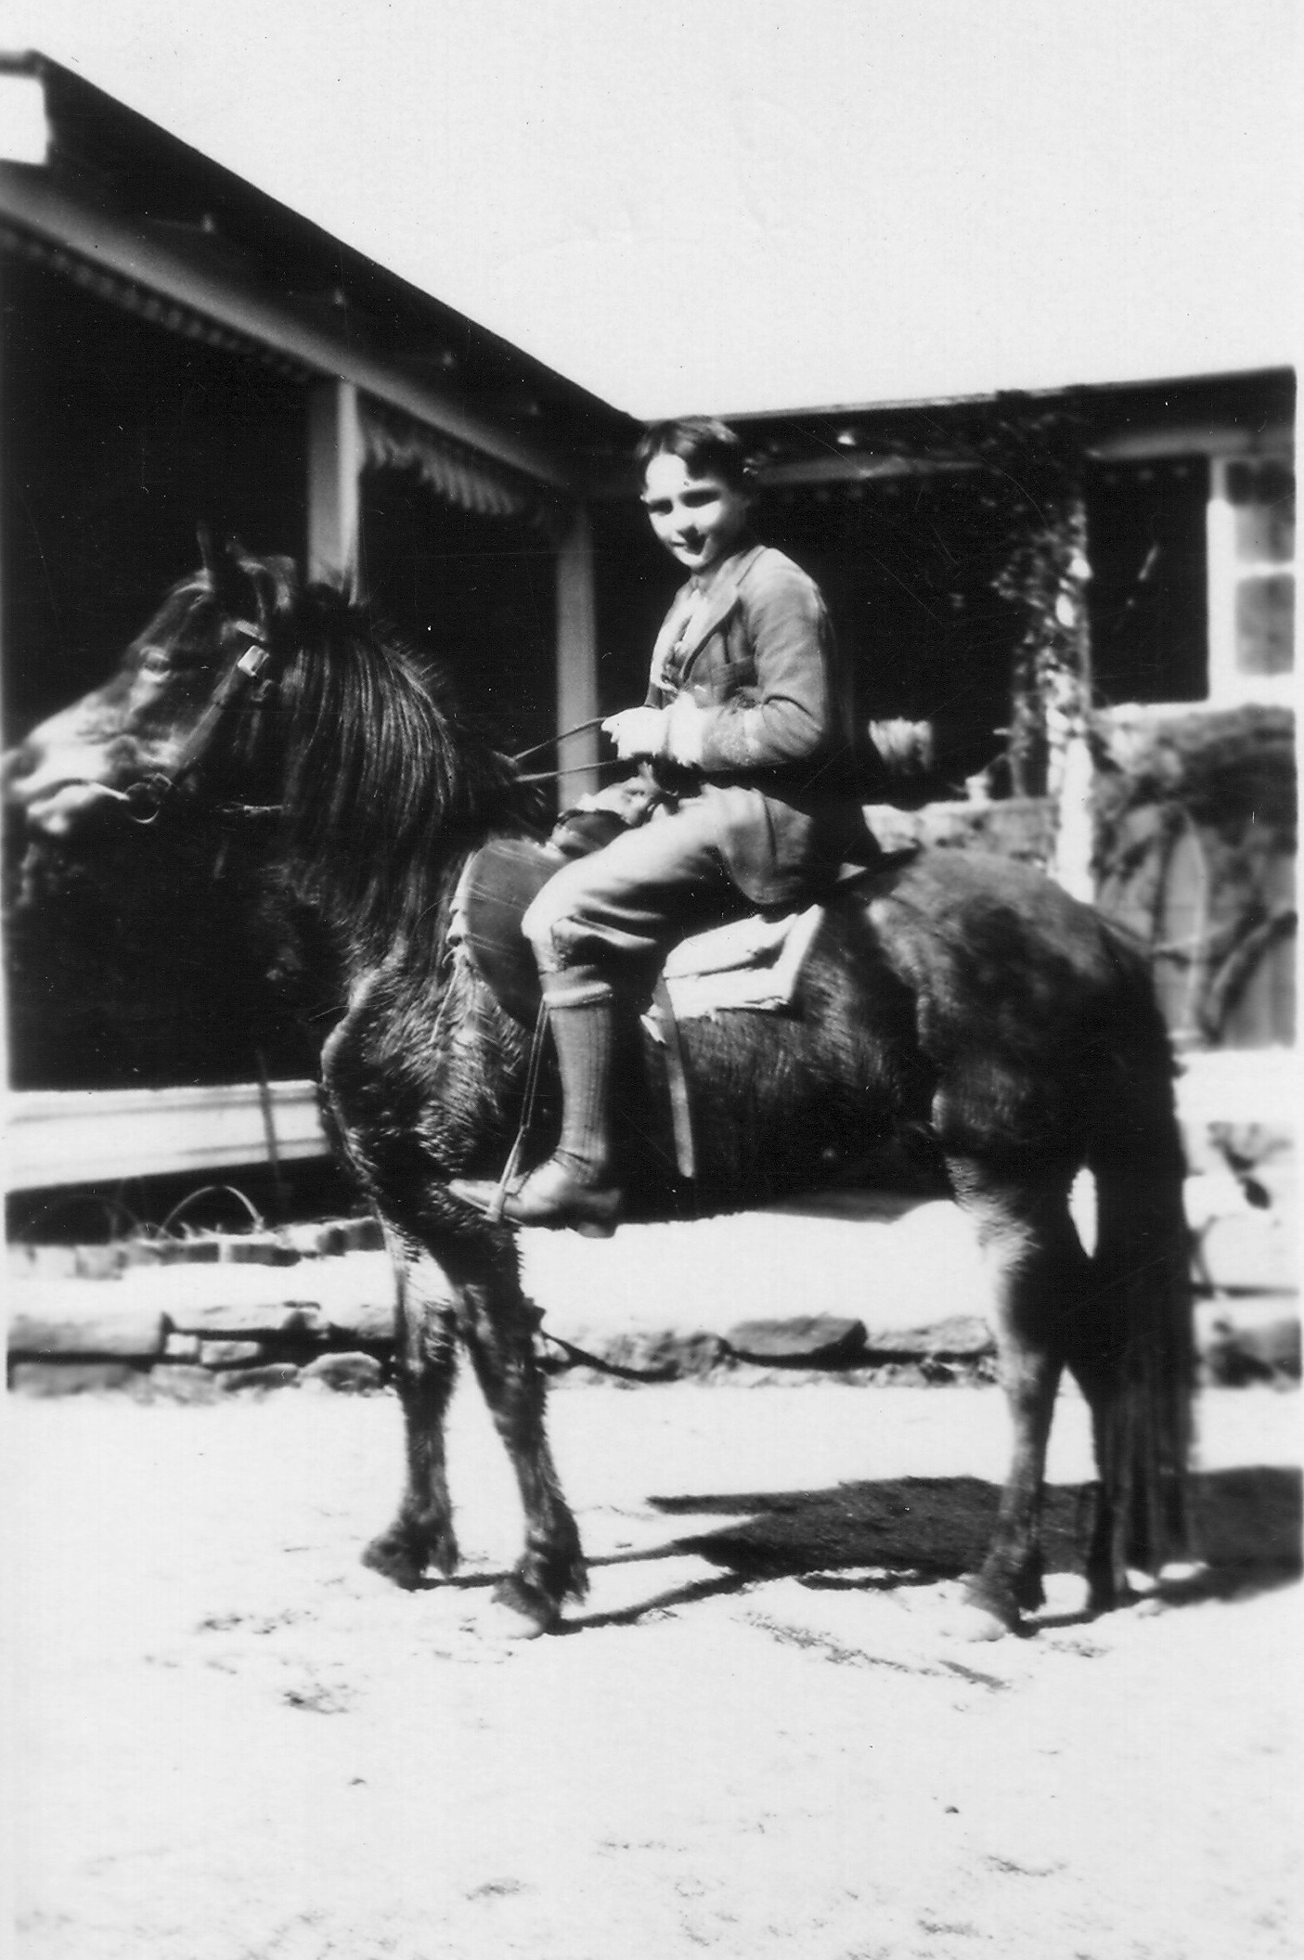
Brian on a horse at
Te Koona

Brian and Pat went to Wimbledon Public School for several years. When the school closed at the end of 1925 due to a lack of pupils, the boys boarded at All Saints College, Bathurst NSW from 1926 to 1929 then they were both enrolled at Geelong College, Geleong, Victoria, commencing on 3 June 1930. Geelong College was chosen because the headmaster and Lyn Haley were friends. Brian remained there until December 1932 when he completed Form VB and was awarded the Arthur South Memorial Prize for a boy showing good work and good example without winning a normal form prize.

After leaving school Brian worked on Te Koona. He and Pat played cricket for Fitzgerald’s Valley in the Bathurst Cricket competition, as did younger brother Peter when he was on holidays from school, all displaying skill with both bat and ball. Brian was mentioned in the National Advocate cricket reports most weeks from 1933 until the end of the season in 1939. It is most likely Brian relocated to Melbourne at some time in this year. In 1946 Lyn Haley donated a trophy to the Bathurst Cricket Association to be known as the Brian Haley Memorial Cup and this was presented to the club by one of his younger sons, Peter. The inaugural winner trophy winner was St Stanislaus College.

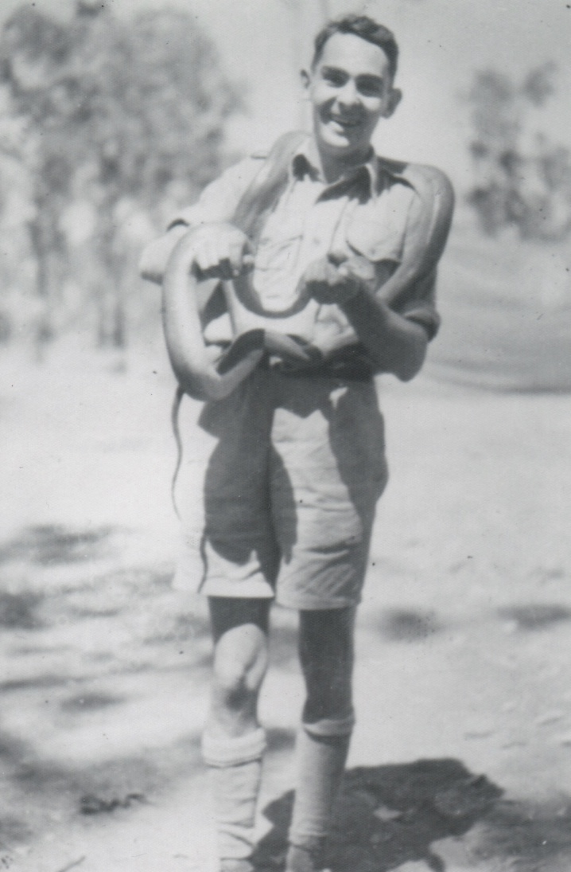
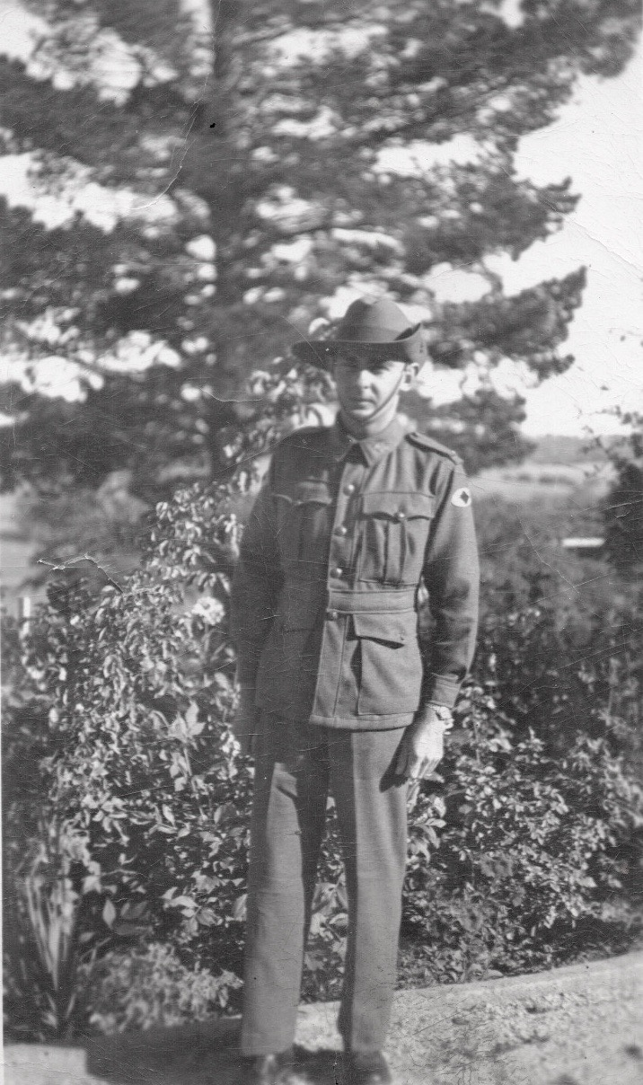
Family members are not sure why Brian left Te Koona to live in Melbourne. Peter once said he thought Brian had been the black sheep of the family and his move was due to being involved with an ‘unsuitable woman”. He may have thought it was time to strike out on his own, choosing Melbourne because of family connections.
Brian at the Darwin training camp with a python
Brian at Te Koona the day before he left to join his battalion

According to the Victorian Electoral Roll Brian was a process worker living at 45 Queens Parade, Clifton Hill, Victoria when he enlisted in the Australian Military Forces on 17 February 1941 although his Australian Army Attestatation Form lists his occupation as a grazier.
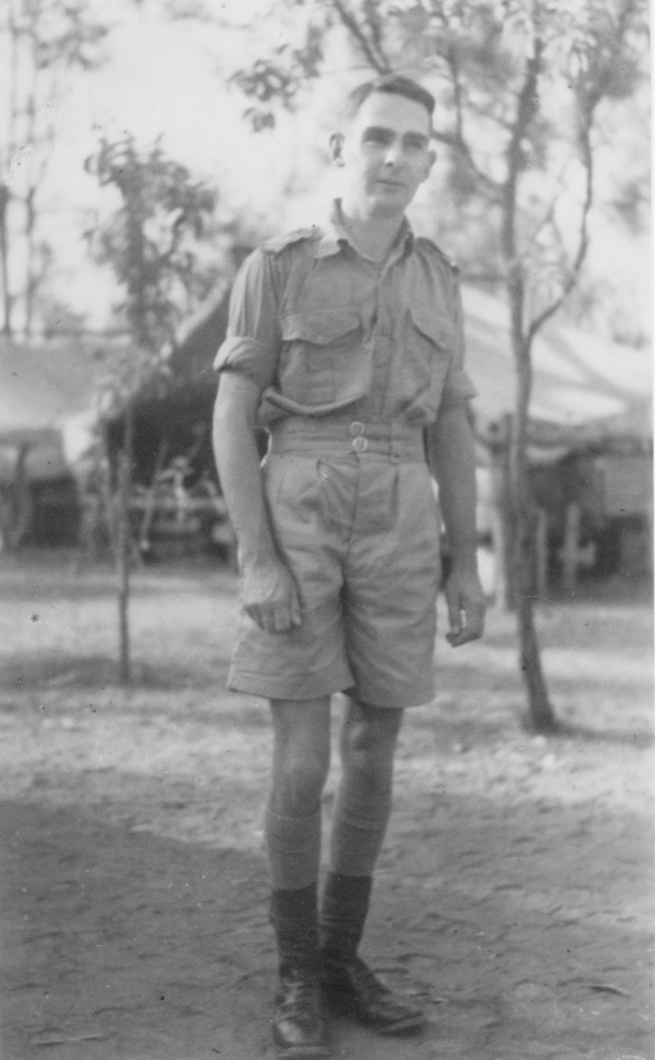
Brian Alexander Evelyn Haley, Service Number VX39736, was assigned as a private to 2/21st Australian Infantry Battalion, known as Gull Force. (The initials before the service number denoted the state where the person enlisted eg Victoria VX, NSW NX). Brian visited Te Koona before he joined his battalion for training. They marched in to Darwin on 12 April 1941 where they undertook more training.
Brian in Darwin, part of the Australian Imperial Force (AIF)

The battalion embarked for overseas service on 13 December 1941, disembarking at Ambon Island. Brian was posted missing on 2 February 1942 and was a prisoner of war by 17 February 1942.

Roger Maynard’s book ‘Ambon’ is one of many accounts of the events that occurred at Ambon at that time. Gull Force, consisting of almost 1200 Australians, mostly from the 2/21st Battalion, was sent to Ambon Island to reinforce the garrison troops of the Netherlands Indies Army. The Australians were deployed to defend the bay and key airfields. The Japanese started invading on 31 January 1942. After a short time the Australians were vastly outnumbered and were forced to capitulate. The former operating base of Gull Force became the POW camp for the rest of the war although some of the troops were transferred to Hainan Island. Most of the POWs were brutalized and suffered diseases like Beriberi and Malaria. Tragically little more than 300 survived.

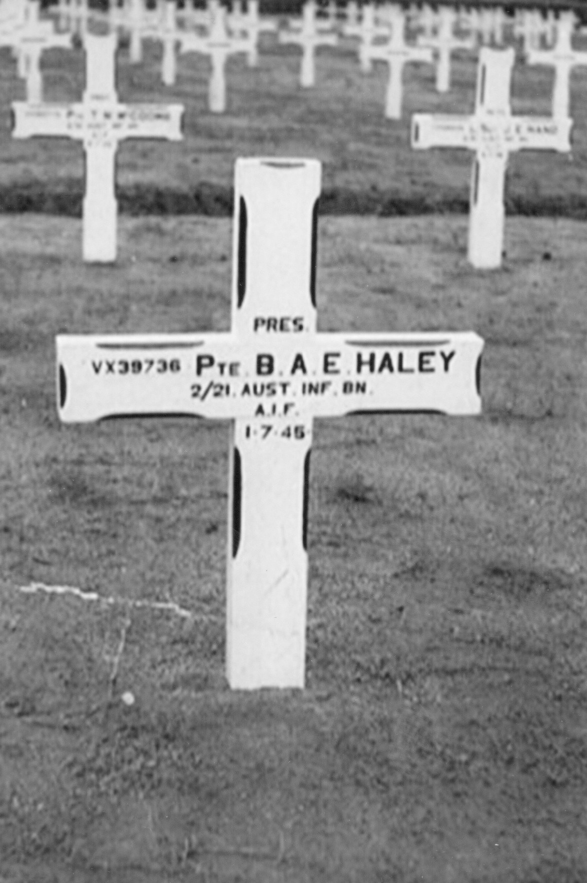
Brian died on 1 July 1945 after contracting Beriberi. Pat remembered his mother receiving a few letters from Brian during the war as well as one from his Commanding Officer when he died telling her that Brian was the strongest of all the men in the corps. His name is listed on panel 46 at the Canberra War Memorial and there is a memorial inscription on the Haley Family vault at Boroondara Cemetery, Kew, Victoria.

The family was issued with the 1939/45 Star, Pacific Star, Defence Medal, War Medal and Australia Service Medal. The whereabouts of the medals is currently unknown.
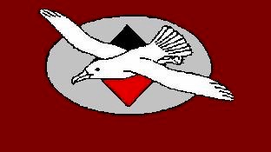
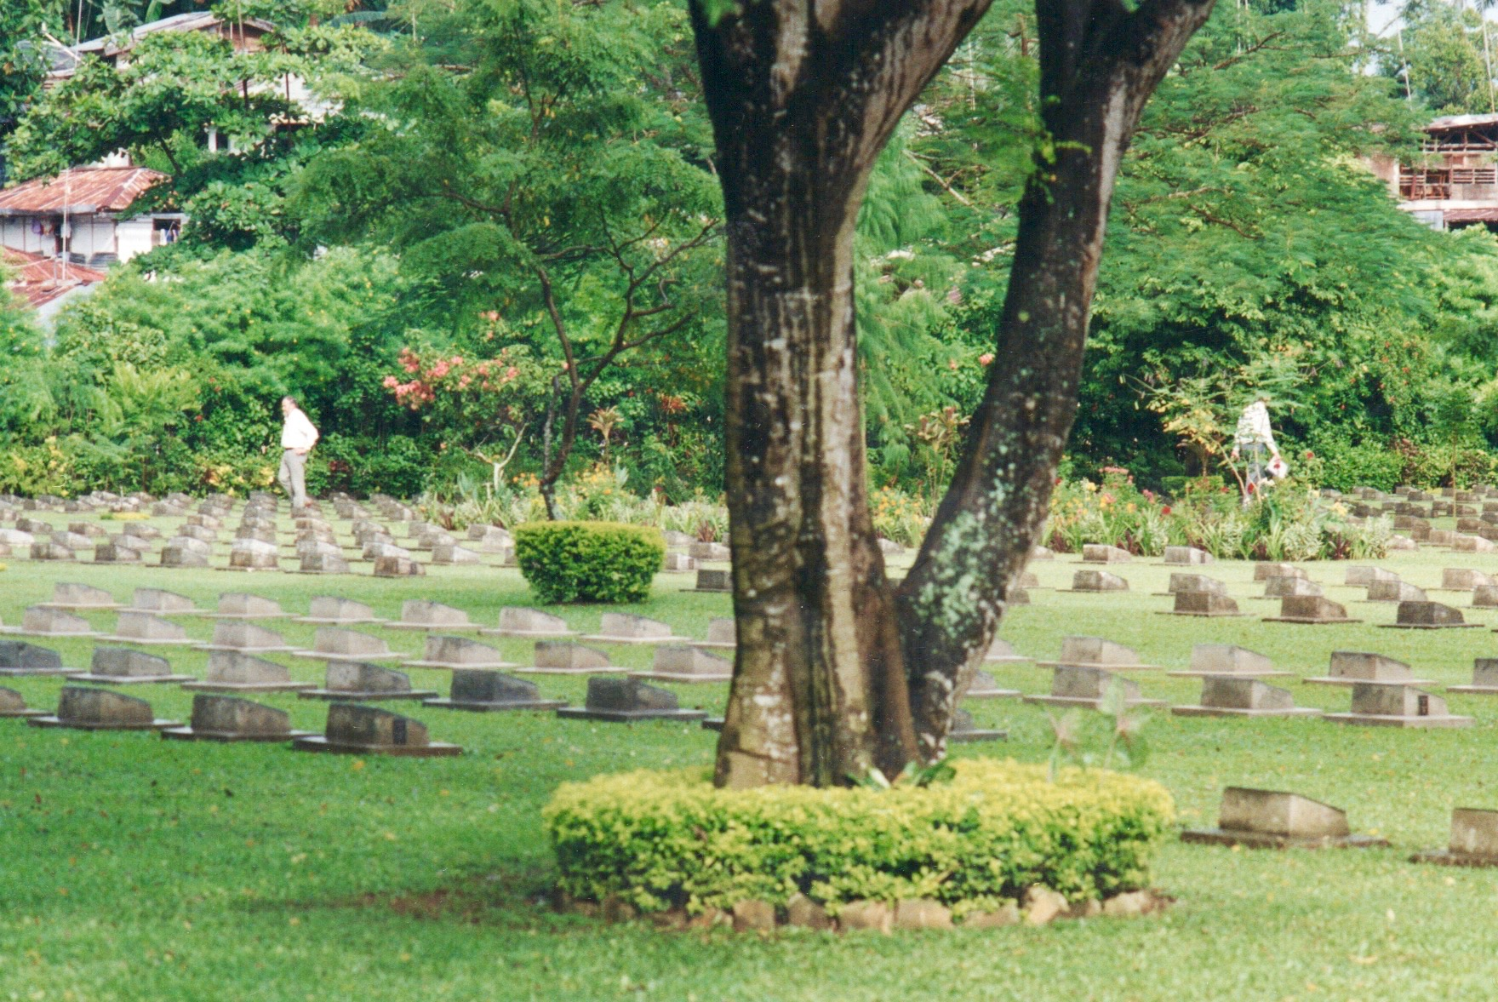
Gull Force Emblem
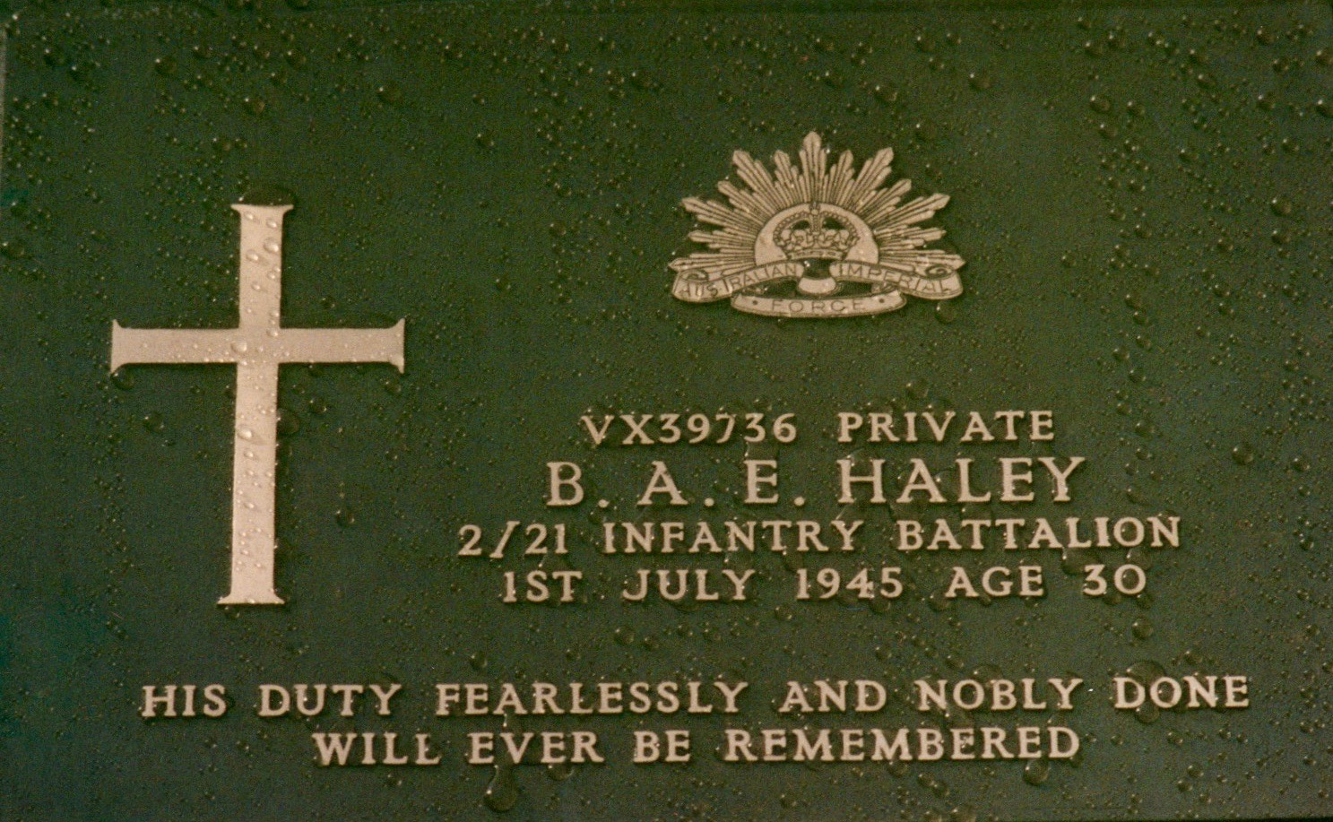
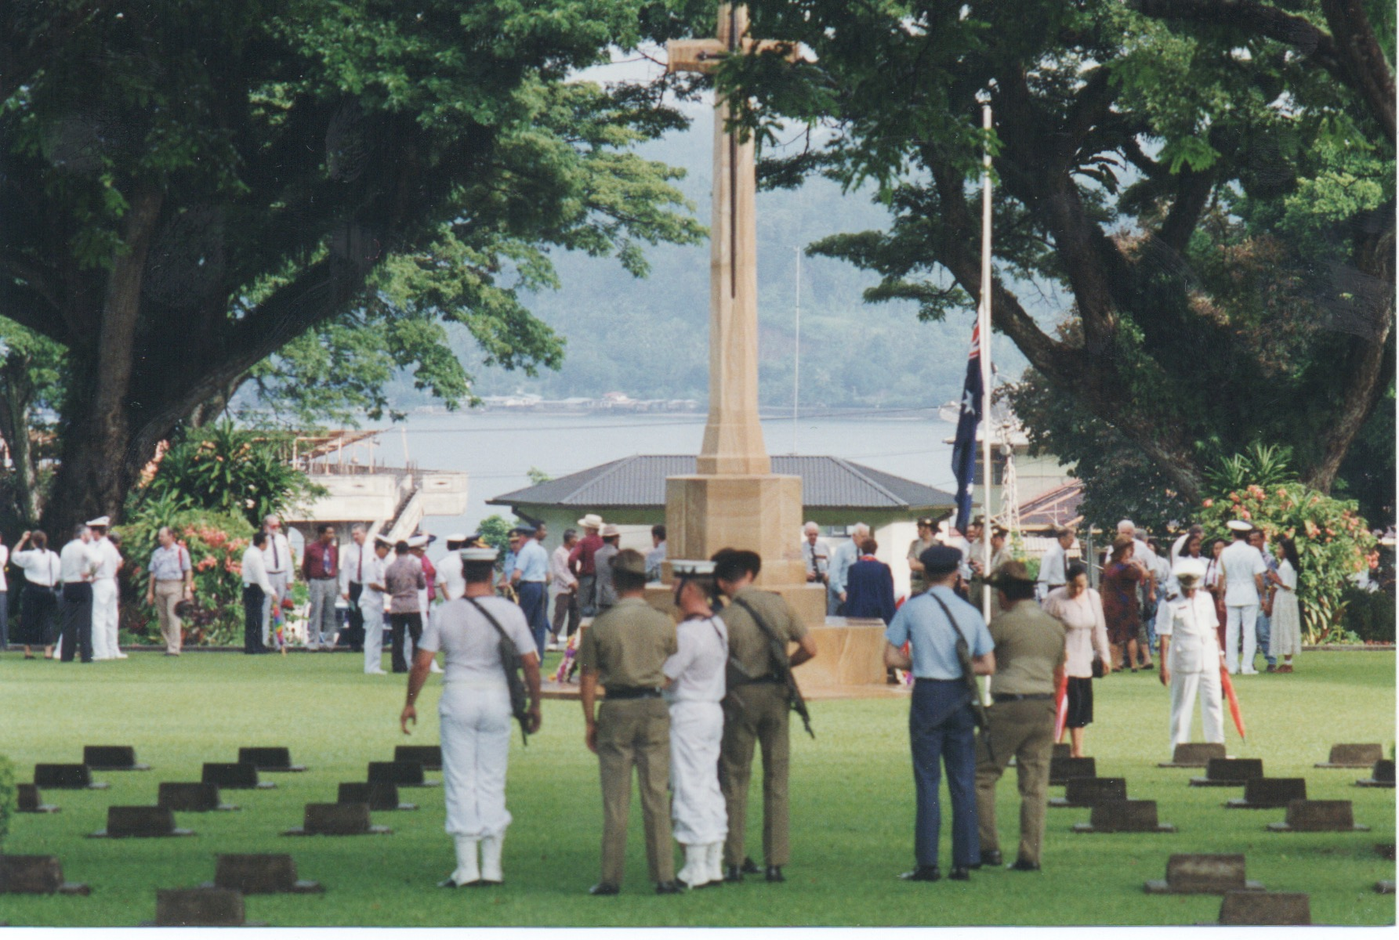
Ambon War Cemetery
Ambon War Cemetery

Gull Force 2/21st Battalion Association has a website with much information about Gull Force. The link can be found at
http://www.gullforce.org.au

